USTruckManager.py

V1.0 User Guide – Alex Dowling-Deslauriers – 2021-01-12

|  |  |  |
| --- | --- | --- |
| **Paperwork/File** | **Purpose** | **Requires** |
| Bill of Lading (BoL) | Required for any commercial load. | Package Count, Weight, Gaylord count (occasionally PAPS# from Tri-Ad). Also print off “Stalco_BoL_Labels.pdf” located in USTM folder |
| Tri-Ad BoL | Requested by Tri-Ad for time-keeping purposes | Sent by Tri-Ad |
| ACE Manifest (JSON) | Sent to Tri-Ad, who uploads to BorderConnect. Lists every package crossing the border for US Customs | Produced by USTM. Requires Batches Scans, ACE and CSV Report |
| ACE Manifest (PDF) | Print the first page off and delivery to driver. Used by customs to match trucks to ACE shipments | Sent by Tri-Ad after we send them the ACE |
| ProForma | Required if FDA-regulated goods are being shipped. Details the FDA-regulated good contained | ProForma Template produced by USTM (requires Batches Scans, ACE and CSV Report). Template uploaded to SmartBorder, where ProForma can be downloaded |
| USPS Manifest Sheets | Given to USPS to process packages | Downloaded from Techship. Attach BoL 1st page to this package |
| IMS BoL | Used by IMS to keep track of gaylords. Also functions as a BoL for IMS | All envelopes to be received. Produced automatically by USTM or done manually |
| DHL Manifest Sheets | Given to DHL to process packages. Include one copy with IMS BoL and staple a second copy to a DHL gaylord | Downloaded from Techship |
| Detailed Report | Copies kept on hand and provided to Tri-Ad to facilitate finding packages when truck is searched | Produced by USTM. Requires Batches Scans, ACE and CSV Report |

# How to Use USTruckManager.py

## Step 1. Closing Manifests

<http://stalco.techship.ca/Orders/Manifests/Open>  
On Techship, close the manifests for today (List as of 2021-01-12):  
 USPS – EHub *(ZS-manifest)*  
 USPS – EHub *(EH-manifest)*  
 USPS – EHub (DCMT)  
 DHL from USA (5121162)  
 FedEx – 673759831  
The manifest for Cuddle & Kind (USPS – EHub (Cuddle & Kind)) should have been closed the day previously.

Once all manifests have been closed, go to the *Manifest History* page  
<http://stalco.techship.ca/Orders/Manifests>  
Select every manifest for the day, including the CK manifest. Download the ACE Manifest and CSV Report (both under the Download dropdown menu)

## Step 2. USTM Setup

W:\Logistics\Tools\USTruckManager

Run USTruckManager.exe

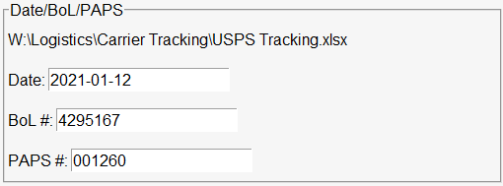

Update the Date/BoL #/PAPS #. See:  
W:\Logistics\Carrier Tracking\USPS Tracking.xlsx

## Step 3. Creating Paperwork

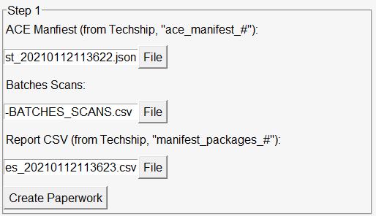

Upload the ACE Manifest, Batches Scans, and Report CSV in the labelled boxes.

Then hit *Create Paperwork*. All the paperwork (except the ProForma) should be generated

### Manifest Hunting

Open the Error_Log.txt file in the folder for today (eg. “\2021-01-31\”)  
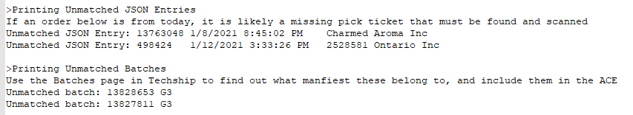  
There are two types of warnings: Unmatched JSON Entry and Unmatched Batch

**Unmatched JSON Entry** means there was an entry in the ACE that was not added because it did not match a scan. If the date is before today, it’s most likely a package that was shipped on a previous day (such as when you’re including manifests from previous days) and can safely be ignored. If the date is today, that means there are orders that *should* have been shipped today but no ticket was received. Consult the following page to check if the ticket was confirmed shipped but never received.  
<https://docs.google.com/spreadsheets/d/13eMd5QOAzYkaRhpenVI_7Byf831EJU7q7b7q74t_u4Q/>  
If you can’t confirm the ticket was shipped, the packages likely wasn’t shipped and can be ignored.

**Unmatched Batch** are much more serious. It means you received a pick ticket for a package going out today but did not provide the ACE data for that package.   
<http://stalco.techship.ca/Orders/Batches>  
Open the above link, set *Status* to “All”, and search the missing Batch #/Pick order #. In the search results, select the Batch. Under the “Manifest ID” column it will tell you a manifest. Go back to Manifest History and re-download the ACE and CSV Report with that manifest included. Re-run USTM with the new ACE/CSV Report. Do this until you stop getting unmatched batches

## Step 4. Proforma and Emailing

In the folder for today there should be a file that ends with “Proforma_Template.xlsx”

Open SmartBorder:  
<https://sbweb.smartborder.com/>  
Click “Proforma”  
On the left, click “Import Proformas”   
Click “Next” as we are uploading this for Stalco  
Drag and drop the Proforma template on to the page. It should give you several warnings (lines are missing Unit of Measurement values). Click “Return to proformas list” and select the most recently upload. Click the bottom-right button, then “Verify”. In the top-right, it should show warnings for the lines. For each line, click on the warning  
  
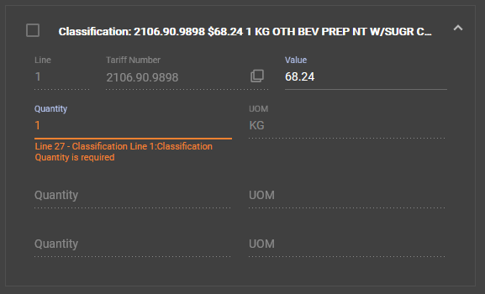  
Wait a moment, then enter “1” in to the Quantity field. Repeat for all lines that need adjustment  
Finally, review the entire Proforma to make sure everything is correct (especially the Total Gross Weight, which tends to be off compared to the BoL. The Shipping Quantity and Total Gross Weight need to match the values on the BoL)  
Save the Proforma, Post to Broker, wait a minute (until the box turns green) and Print. This will download a copy of the Proforma

Return to USTM  
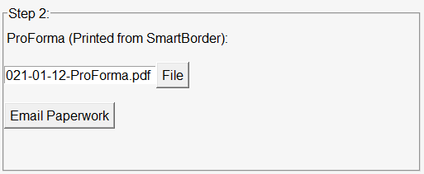  
Upload the Proforma in the labeled box  
Now is a good time to review all the file generated to make sure they do not have errors  
If all the files were successfully generated, it will open 2 message boxes asking for your email account username and password. Once entered, USTM will automatically email all involved parties with the paperwork. Done!

# Advanced Features

USTM supports multiple advanced features for when things go wrong.  
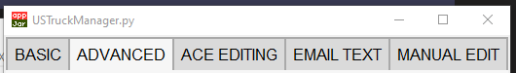  
Basic

This is the basic UI covered above. On a problem-free day, it is the only page you will need to use.

## Advanced

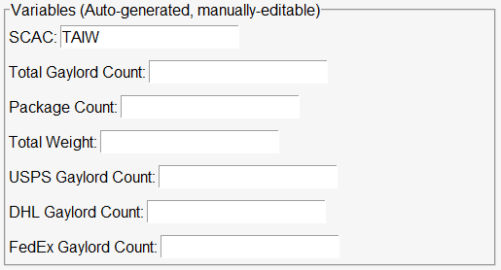  
The top box contains values that are automatically generated while making the paperwork. These values can be edited when needed (such as when a different carrier is carrying the load, or when gaylords have been consolidated and the batch scans sheet lists more gaylords than loaded on to the truck)

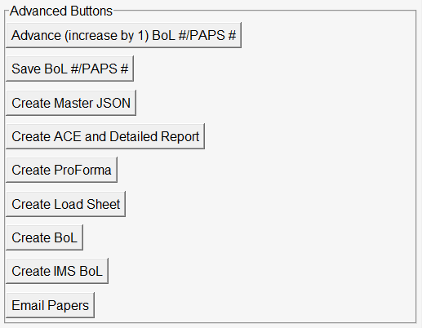  
These buttons allow you to generate the paperwork one step at a time. Note that lower buttons tend to rely on higher buttons to be clicked first (eg. To produce the ACE you need the Master JSON created, etc).

## ACE Editing

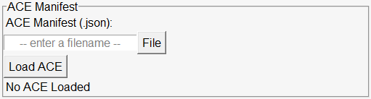  
Upload the JSON file then click “Load ACE”  
If successful, the bottom line should update to “X ACE Entries loaded”

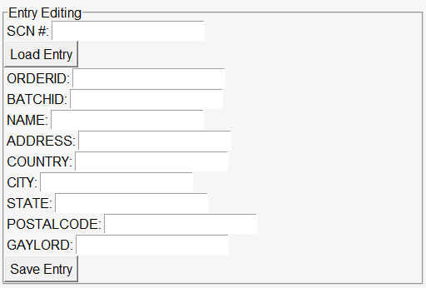  
After the ACE has been loaded, you can enter in the SCN of an individual entry. Click “Load Entry” to see its contents. You can check/edit the values before saving with “Save Entry”.

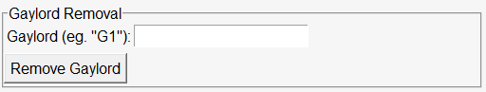  
When the FDA rejects a load, this tool can be used to remove those gaylords from the ACE manifest. Remember to use the same ACE you sent to Tri-Ad. Consult the Detailed Report to verify which gaylords contain items that necessitate the gaylord being removed.

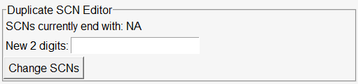  
Occasionally Tri-Ad will get duplicate ACE entries. This happens when they upload an ACE containing entries, and then at a later date try to re-upload those entries on to a new shipment (such as trying to reship packages that were originally not allowed to cross eg. Any 321 packages in a gaylord that held FDA-regulated packages and needed to be held). If an ACE is loaded, the subtitle will read “SCNs currently end with: XX” where XX is usually 00. Enter in the new SCN ending (eg. 01) and click “Change SCNs” to save the ACE

## Email Text

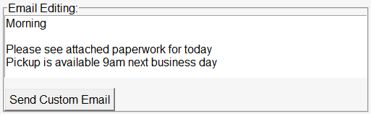  
This page allows you to edit the message sent with the paperwork, instead of resorting to manually sending emails with corrected information. Note that the “Send Custom Email” button requires all forms to be generated and the ProForma to be uploaded on the first page.

## Manual Edit

These tools are the ones you use when things go wrong.

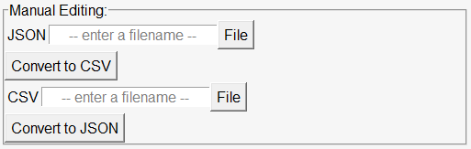  
These two boxes allow one to convert ACE Manifests (JSON files) to CSV (openable in Excel). This allows for simplified editing, such as removing entire gaylords/products/clients from the ACE. The second tool allows you to convert the CSV back to JSON to be uploaded.  
  
Pictured: An ACE Manifest converted to JSON format

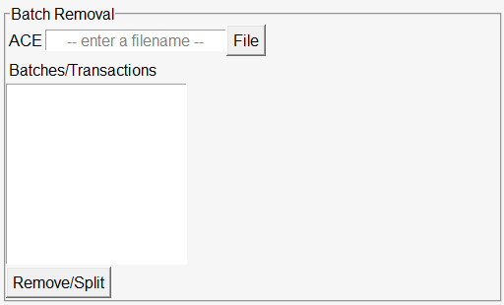  
This tool allows you to remove specific batches/transactions from an ACE, such as when only a few orders from a batch can not be shipped due to missing product. Note that it splits the manifest in to 2: the first manifest contains all the entries that did not match, the second manifest contains the entries that did match.

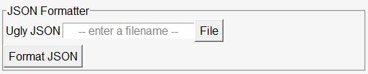  
This tool is used to make ACE manifests human-readable. It can also be used to check if a JSON is valid.  
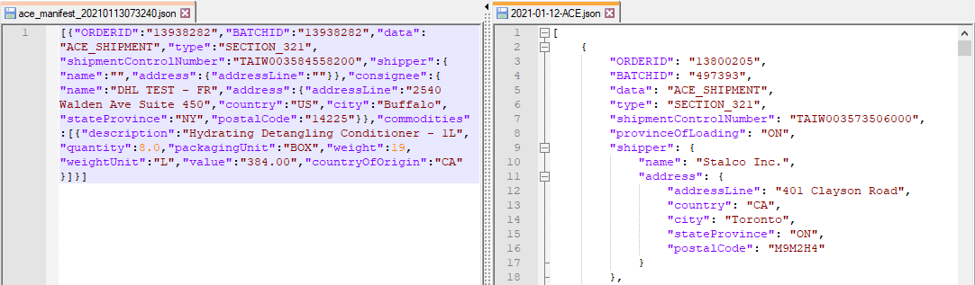  
Left: Sample unformatted JSON (from Techship)  
Right: Sample formatted JSON

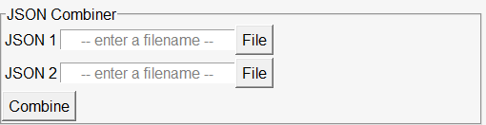  
This tool is used to combine 2 ACEs, such as when you removed orders from a previous day’s ACE and want to add them to today’s ACE.

# SmartBorder Login Details

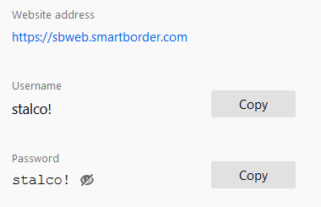

# Paperwork

All files (except the ACE, as stated below) can be found in:

W:\Logistics\USPS Customs\USPS Customs Paperwork\IMS Invoices - Mixed Shipments\[YYYY]\[MM]\[Date]

Print and give to Driver:

- 1 copy of the first page of the ACE manifest provided by Brandy (usually by 10am Sunday)

- 1 copy of ProForma, stapled

- 1 copy Load_Sheet.pdf

- 2 copies of IMS-BoL.pdf. Given to driver. Paperclip to:

- 1 copy of the DHL manifests, stapled

- 1 copy of the Stalco BoL, signed by you, stapled to the USPS manifests

- 1 copy of the Stalco BoL, signed by you, stapled to:

- 1 copy of Stalco_BoL_Labels.pdf, found in W:\Logistics\Tools or W:\Logistics\USPS Customs

Additionally, include the following:

- 1 copy of the DHL manifests, stapled to one of the DHL gaylords

# Troubleshooting Common Errors

# How to remove Gaylords

If the FDA rejects a product/holds it for inspection it may be necessary to remove the products/effected gaylord from the ACE to allow the rest of the products to cross the border. Open USTruckManager, and select the third tab, “ACE EDITING”. Upload the ACE manifest.

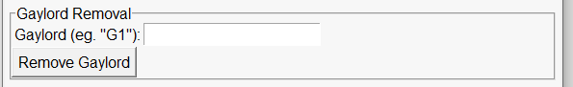

Specify the Gaylord you wish to remove (eg. “G12”) and click “Remove Gaylord” and re-send the ACE to Tri-Ad. They will have to clear all the old shipments and re-upload the new ACE.

# Duplicate SCNs

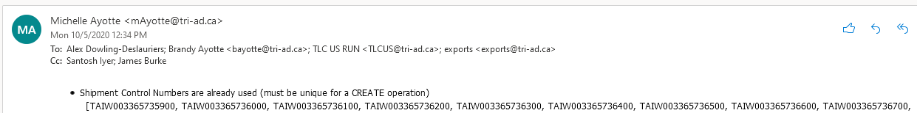

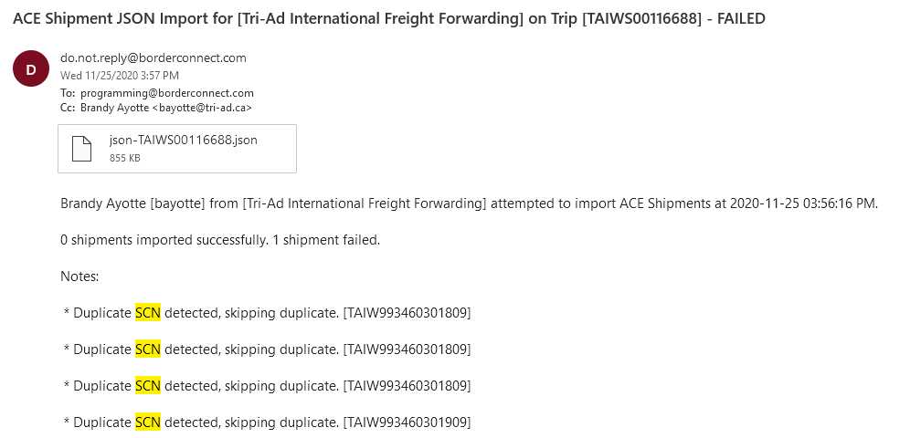

**Cause:**  
Occurs when (entries from) an ACE manifest is uploaded to BorderConnect once, and then the same entries/ACE is attempted to upload again.  
This occurs when Tri-Ad has to remake a trip, or when a package is included on an ACE manifest when it was shipped previously (common around weekends).

**Solution:**

Open USTruckManager and navigate to the third tab, “ACE EDITING”. Upload the ACE.

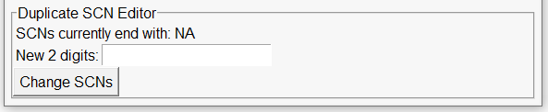If the ACE successfully uploaded, it should display the current SCNs ending as “SCNs currently end with: XX” where XX is the ending (usually 00). Enter in a new ending (eg. 01), click “Change SCNs”, wait a moment for USTM to do its magic, and then re-send the ACE manifest

# “Commodity Value is Missing”

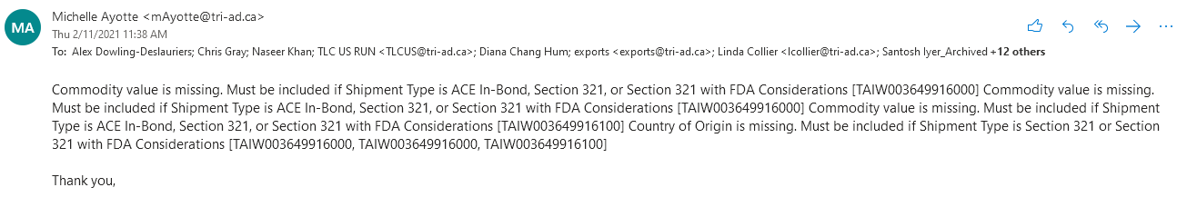**Cause:**  
FDA-cleared products/entries from EH-manifests lack Commodity Value fields. If a FDA-regulated product is added to the ACE (such as a new SKU being added without informing the Logistics team) it may end up on the ACE and cause this issue.

**Solution:**  
Using the Detailed Report, identify the Client shipping the effected SKU(s). Add said client to the FDA_CLIENTS.json file. Copy and paste the name from the Detailed Report as the name has to *exactly* match in order to work.

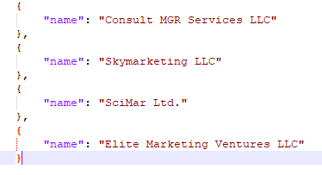

Once updated, re-run USTM as usual. The effected entries should be caught by the FDA-client identifying subroutine and not placed on the ACE. Re-send the ACE to Tri-Ad.

# Editing Individual ACE Entries

**Cause:**  
USTM has a ACE verification sub-routine that should automatically correct mismatched states/too long names/addresses. Sometimes stuff slips through, however.

**Solution:**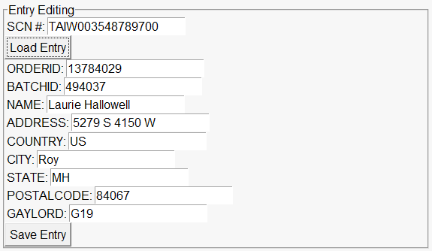

Load the ACE and manually edit the offending entry

# Too Many Shipments

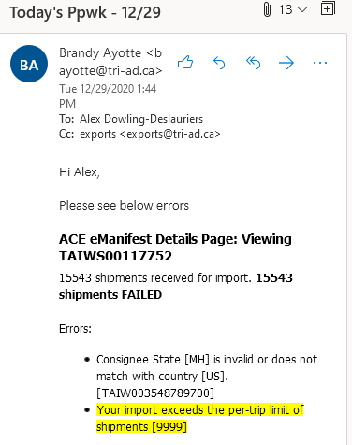

**Cause:**  
If you try to upload an ACE with more than 9999 shipments BorderConnect will throw an error (this may happen on very large (20+ gaylords) loads).

**Solution:**  
Brandy at Tri-Ad is trained in how to handle imports on her end. We just need to split the manifest in to 2 parts so they can upload each. Open the 5th tab, “MANUAL EDIT”. Upload the ACE and click “Convert to CSV”. In the same folder as USTruckManager there will now be a file called ACE_Manifest_(CSV).csv. Open this file. You want to split this file in to 2 parts. If the original file is (for example) 30,000 lines long, split it in to 2 files that are 15,000 lines long. Create 2 new CSV. Copy and paste half of the lines in to one, and half in to the other. Column E is the SCN – make sure you split the lines at a point where the shipment control numbers change.

# 

*Above: note how the SCN changes from lines 13427 to 13428. Split the manifest here, such that 2 different manifests do not include the same SCN*

Save both CSVs, noting which is part 1 and which is part 2. Using USTruckManager, tab 5, “MANUAL EDIT”, upload each CSV to the second box, “CSV” and then click “Convert to JSON”. Send both of these files to Tri-Ad.

# BACKUP: 2 Manifests Instructions

Included in case Brandy is not available. Provide this info to Tri-Ad

1. Upload the attached “1_ACE_Manifest_(JSON).json” file to the current trip. It’s under 9999 shipments and should upload fine. Change the trip number for that trip to end with “A” to signify it’s the first part  
2. Create a second, “dummy” trip with all the same details as the first. Set the trip number the same as the first, but ending with “B” for the second part. Specify the second ACE “2_ACE_Manifest_(JSON).json” but don’t click “Save”  
3. Below where you can attach the JSON, there is a option to show the option to link shipments to another trip. Click “Show”. (See “bcoption1.PNG”)  
4. A new option should appear up top, beside the usual input fields, “Link Shipments to Trip”. Specify the first trip. This should send an amendment request to CBP, adding the second trip’s JSON to the first trip (see “bcoption2.PNG”)  
5. Print and attach to the email the second ACE manifest alongside the first   
6. **The driver MUST state to the CBP officer that he's got two manifests for the single truck because the volume exceeded the ACE limit of 9,999 shipments per manifest. All shipments from both manifests are on the truck.**

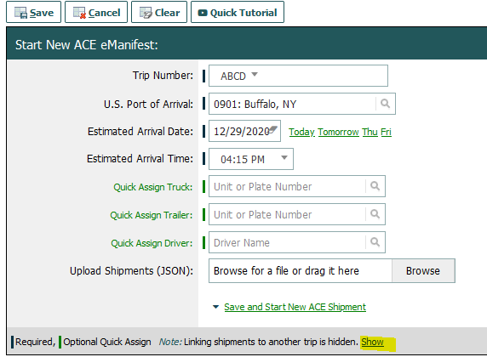  
  
  
  
  
  
  
  
  
  
  
  
  
  
  
  
  
  
  
  
  
  
Above: bcoption1.PNG

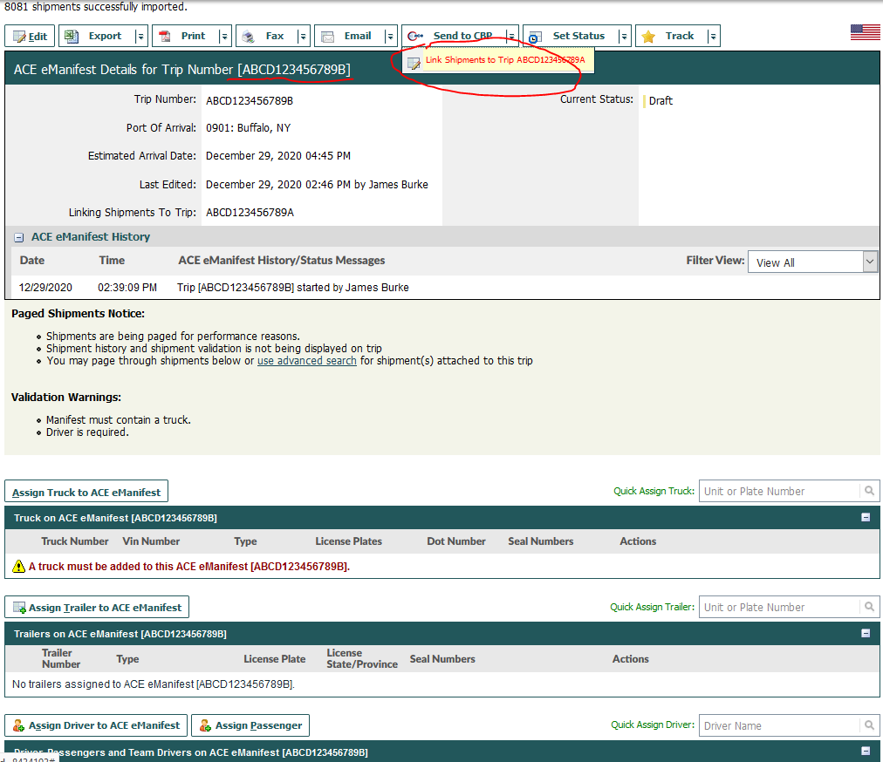Above: bcoption2.PNG

# Removing Batches/Individual Orders from the ACE

If you have to remove a specific batch/order from the ACE I would recommend removing it from the BATCHES_SCANS.csv and re-running USTM. This will update all the paperwork, ensuring correctness.

**Solution:**  
You know the drill. Tab 5, “MANUAL EDIT”, upload ACE, specify batches and/or transactions to remove from the ACE, click “Remove/Split”. “ACE_Manifest_(1).json” is the good JSON, “ACE_Manifest_(2).json” holds all the orders you removed.